Streamlining Credential Verification for Hiring Processes with Blockchain Technology

Now-a-days companies are colleges are solely dependent on manual process to validate student academic credential which can lead to fake verification by giving bribe to verification employees. In the past to fight such fake verifications some universities started to maintain student credential in centralized servers where companies can utilize this centralize server services to validate credentials but this centralized servers also not 100% genuine as internal database admin can alter centralized server database and can be hack also and in such situations centralized server get down and services will be disturbed.

To overcome from above drawbacks we are employing Blockchain based student credential verification. Blockchain has inbuilt support for data verification, encryption as distributed data storage. Blockchain will store data in multiple nodes as distributed format and if one node down then services can be obtained from other working nodes.

Blockchain has inbuilt support for tamper proof data storage as it can store each data as block/transaction and associate each block with unique hashcode, while storing new record Blockchain will verify all previous blocks hashcode and if data not tamper then it will result into same hashcode and verification get successful and if alter then it will result into hashcode mismatch and verification will get failed and data tamper will get detected. Due to this reason Blockchain is proof as tamper proof.

Because of above advantage we are migrating student credential storage to Blockchain and this applications consists of 3 modules

1. University: universities can sign up and login to application, after login they can enrol student into various courses, after completion they can upload certificate to Blockchain, under single student ID they can upload multiple certificate. Each certificate will be identified with unique hashcode address. Universities can see list of students added to different course. (note: in your requirement you said that student will upload certificate to Blockchain and then university will approve but in real time university only responsible to issue certificates so we changed this module)
2. Company: companies can sign up and login to application and then can view list of students and then can send certificate access request to desired students. Once request approve by student then company can see all certificates of that student
3. Student: university will issue student id to each student and by using that ID they can login to system. After login they can view their course details, can view certificates, can view company access request and can approve company request.

To implement above modules in Blockchain we need to develop smart contract using solidity programming and this contract contains functions to save and get student credentials from Blockchain. In below screen we are showing smart contract designed to manage credentials

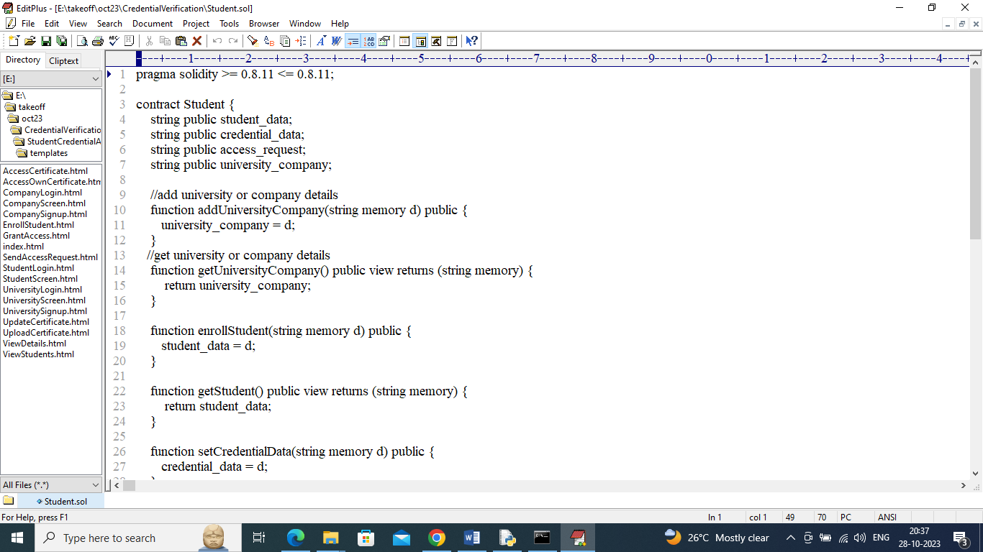

In above smart contract for each module we define functions and this functions can be called to read and saved data in Blockchain. Now above contract we need to deploy in Ethereum by using below steps

1. Go inside ‘hello-eth/node-modules/bin’ folder and then find and double click on ‘runBlockchain.bat’ file to start Ethereum and will get below screen
2. 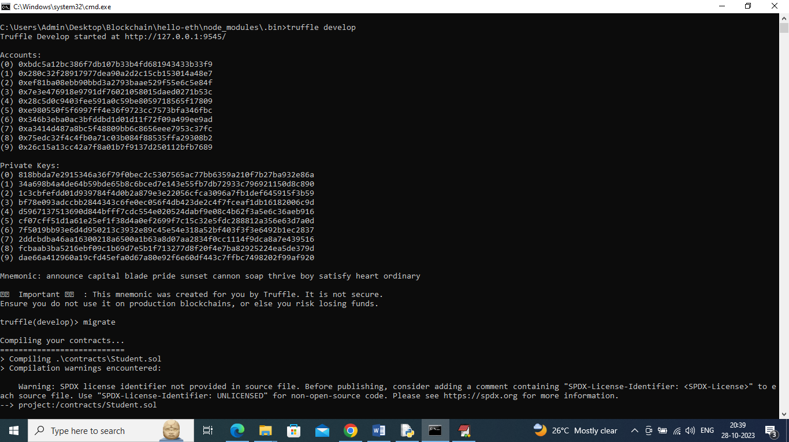
3. In above screen Ethereum started with default accounts and private keys and now type command as ‘migrate’ and press enter key to deploy smart contract in Ethereum and after deployment will get below screen
4. 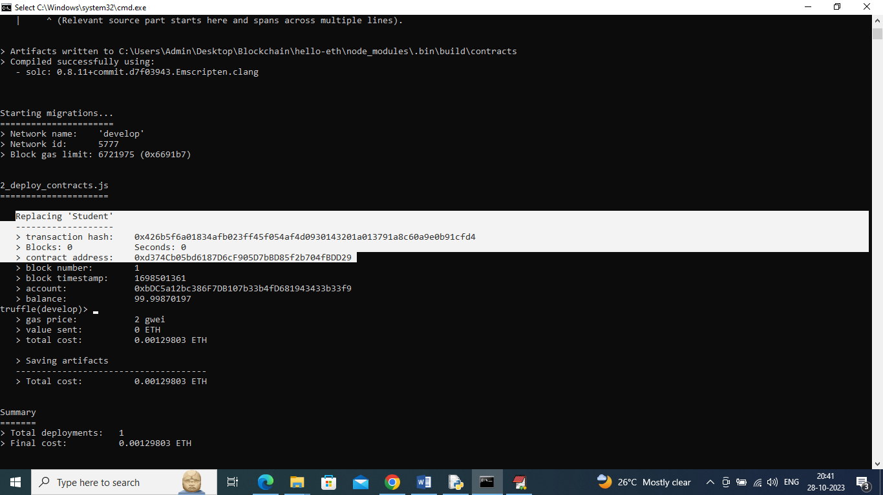
5. In above screen in white colour text we can see ‘Student’ smart contract deployed and we got contract address also and this address we need to specify in python program to call that contract to store and read student details. In below screen showing python code calling smart contract from Ethereum
6. 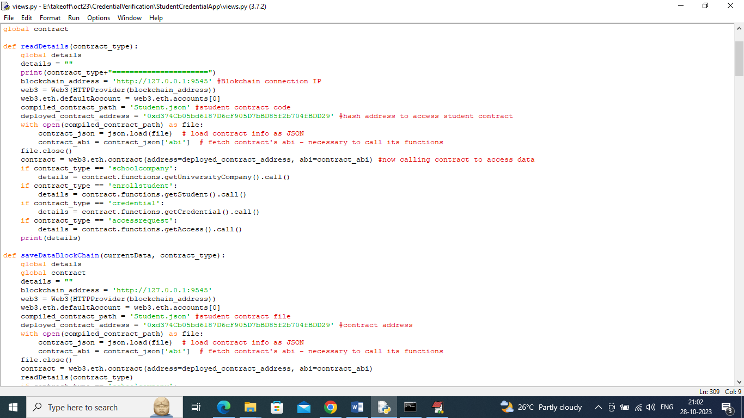
7. In above screen read red colour comments to know about contract calling from python using contract address. Now in above screen we can see contract deployed and Ethereum server also running and let that server run

SCREEN SHOTS

To run project double click on ‘runServer.bat’ file to start python server and get below page

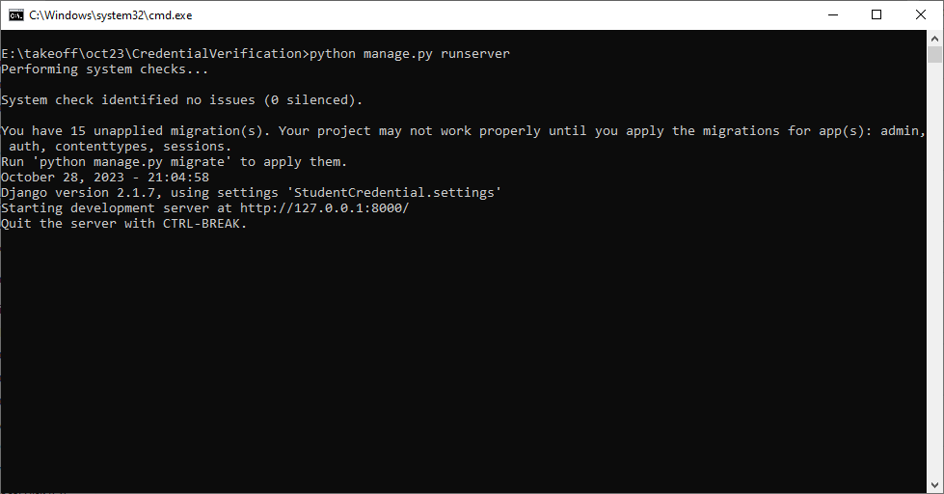

In above screen python server started and now open browser and enter URL as <http://127.0.0.1:8000/index.html> and press enter key to get below page

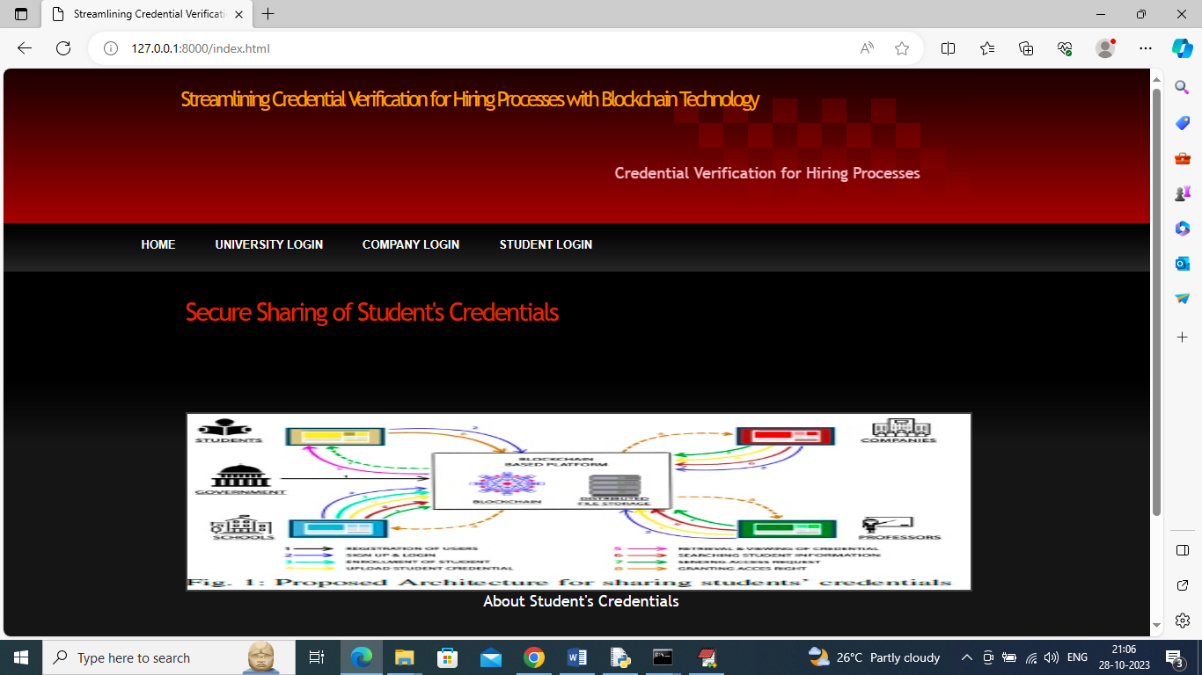

In above screen click on ‘University Login’ link to get below page

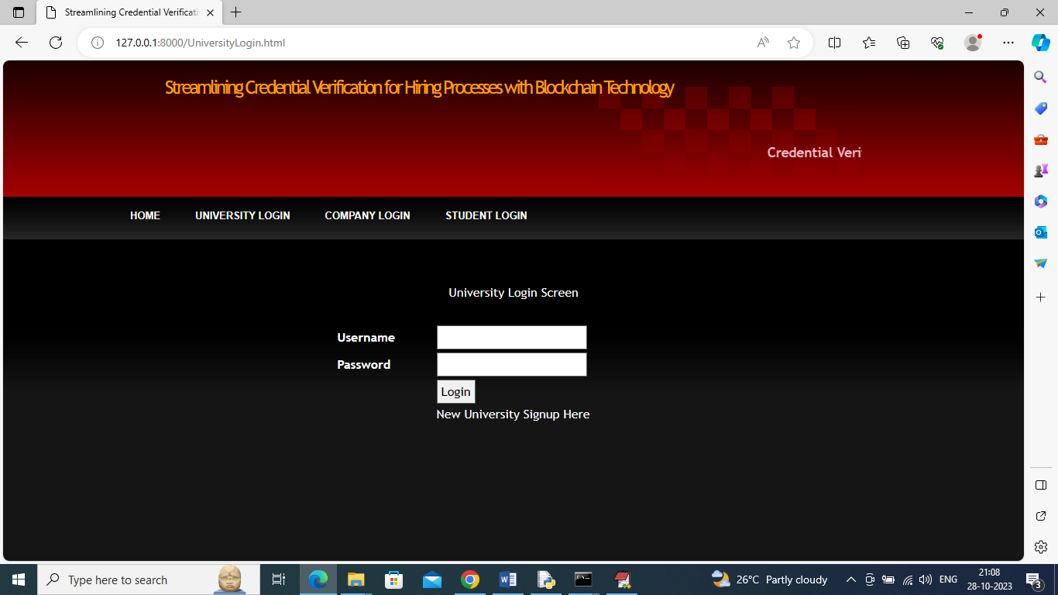

In above screen click on ‘New University Signup Here’ link to get below signup page

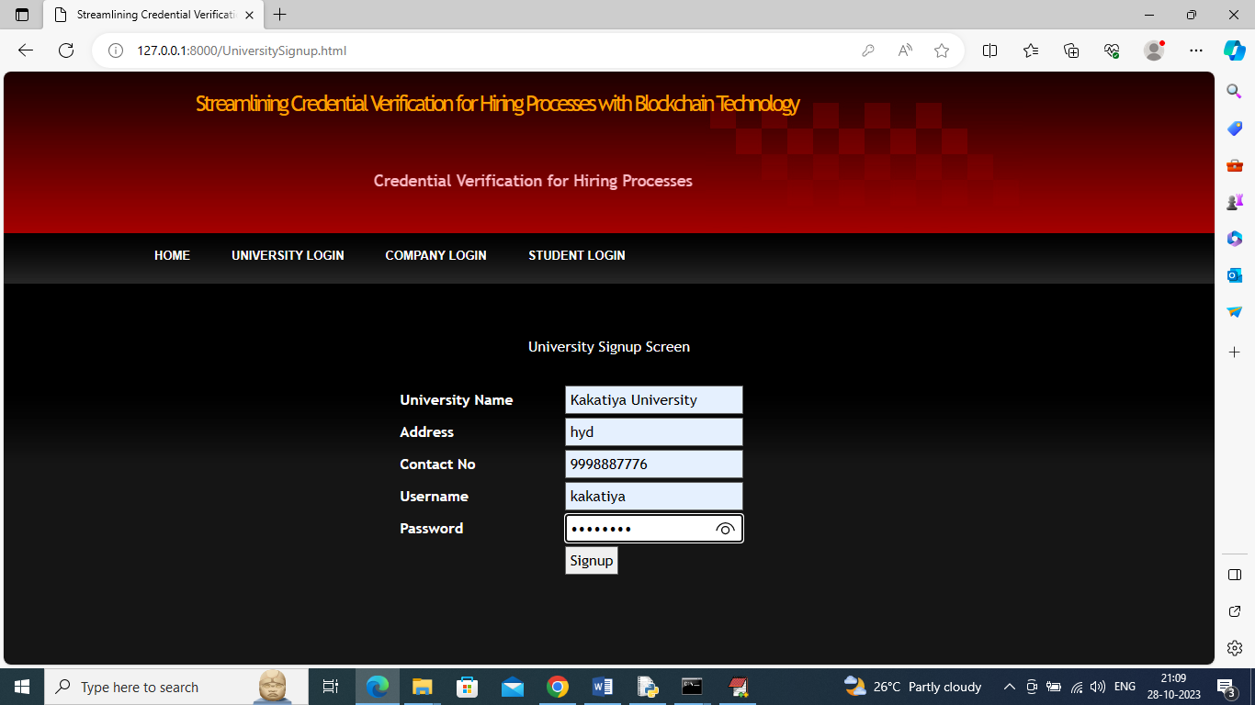

In above screen adding university signup details and then press button to save details in Blockchain and get below page

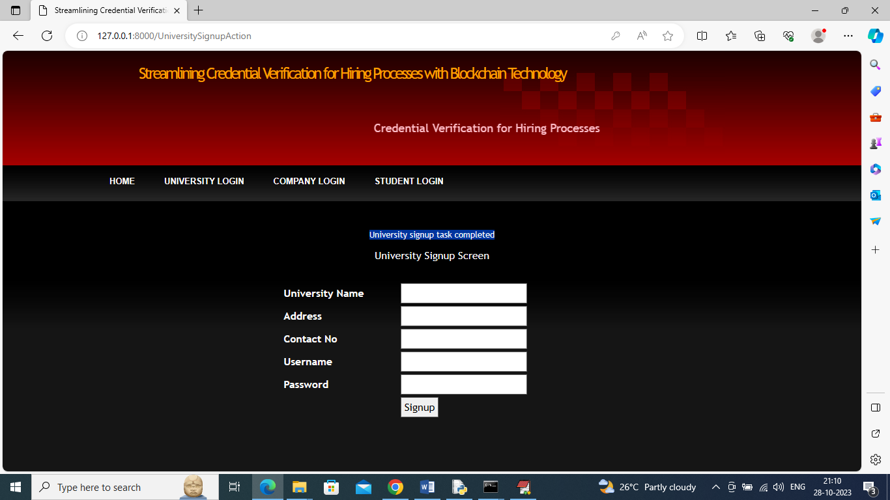

In above Screen University signup completed and now click on ‘Company Login’ link to get below page

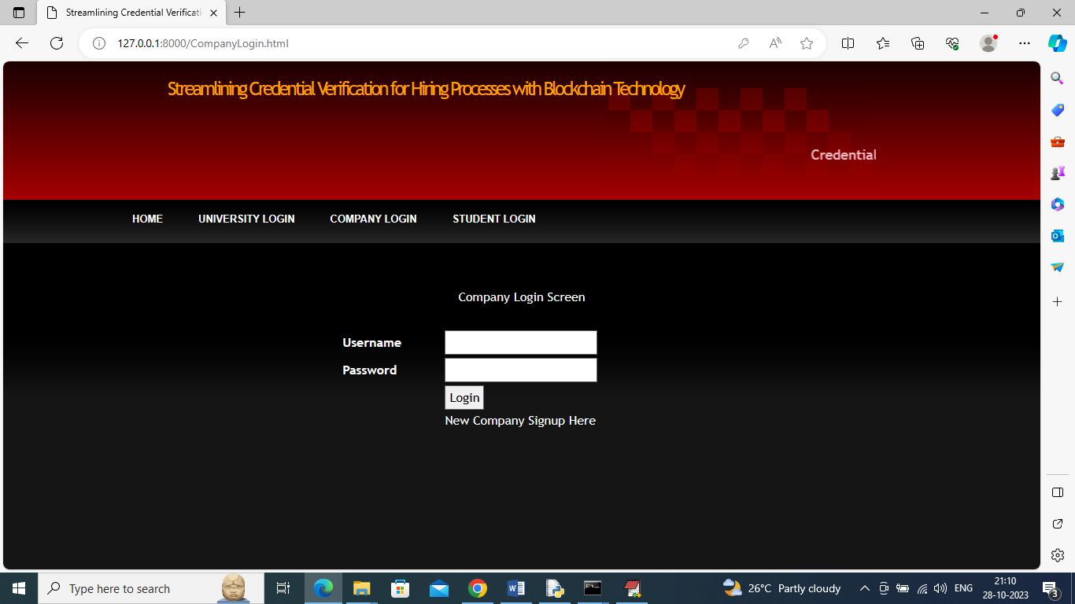

In above screen click on ‘New Company Signup Here’ link to get below company signup screen

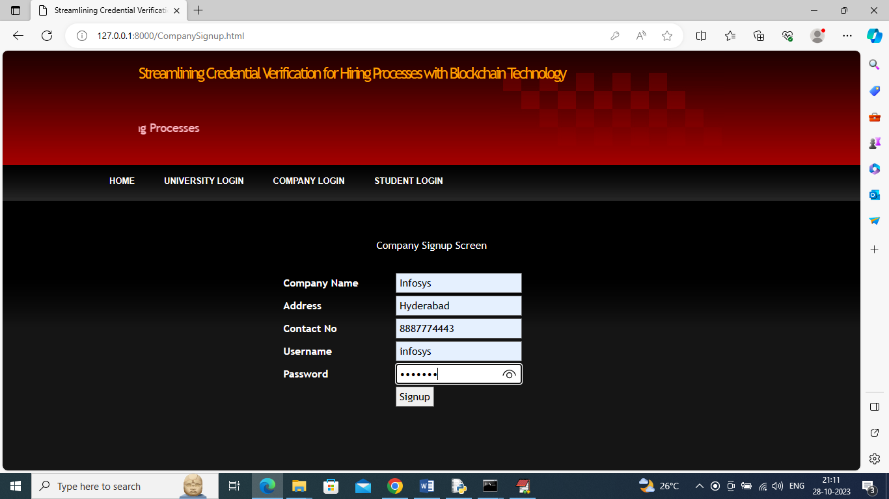

In above screen adding company details and then press button to save company details in Ethereum and get below page

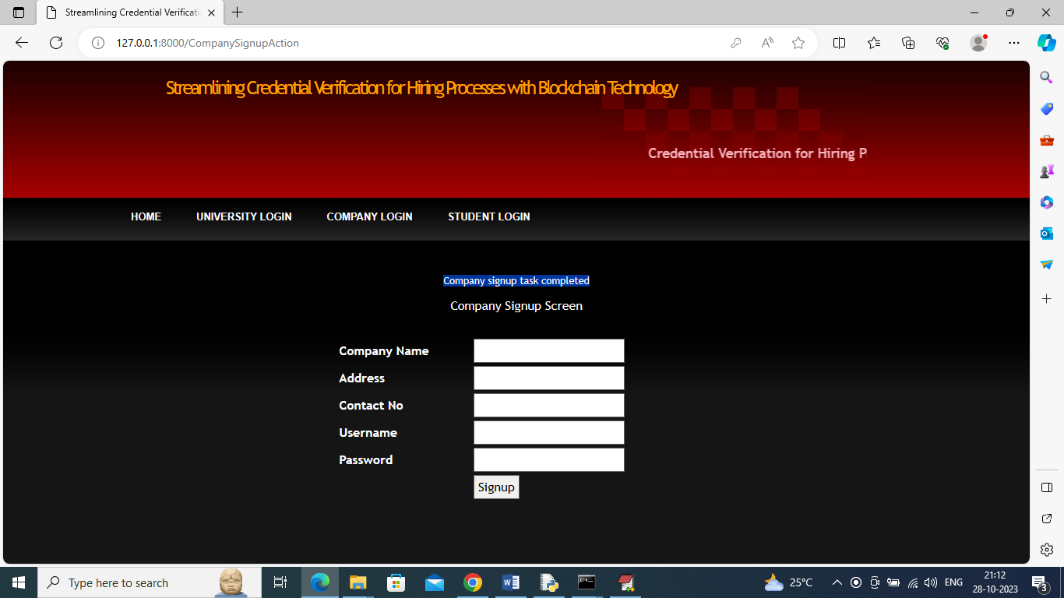

In above Screen Company signup completed and now click on ‘University Login’ link to get below page

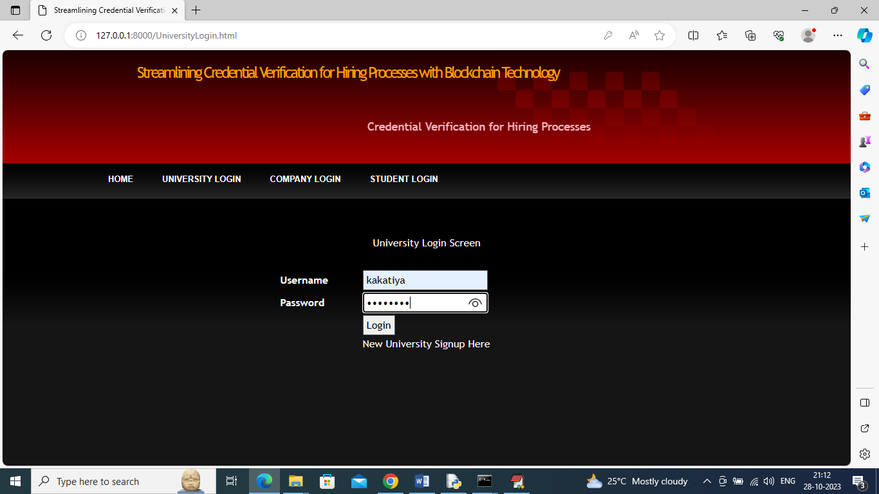

In above screen university is login and after login will get below page

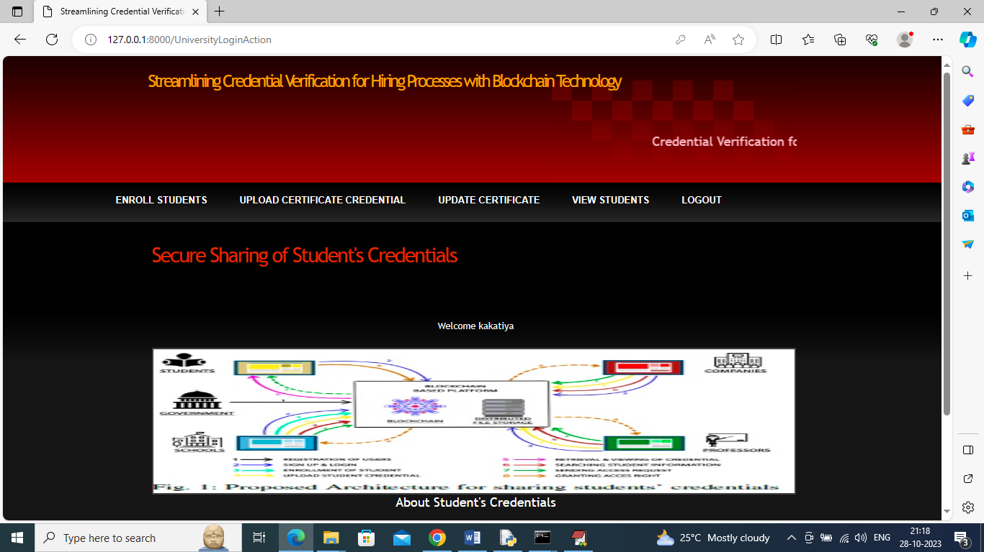

In above screen university can click on ‘Enrol Student’ link to add student details in Ethereum

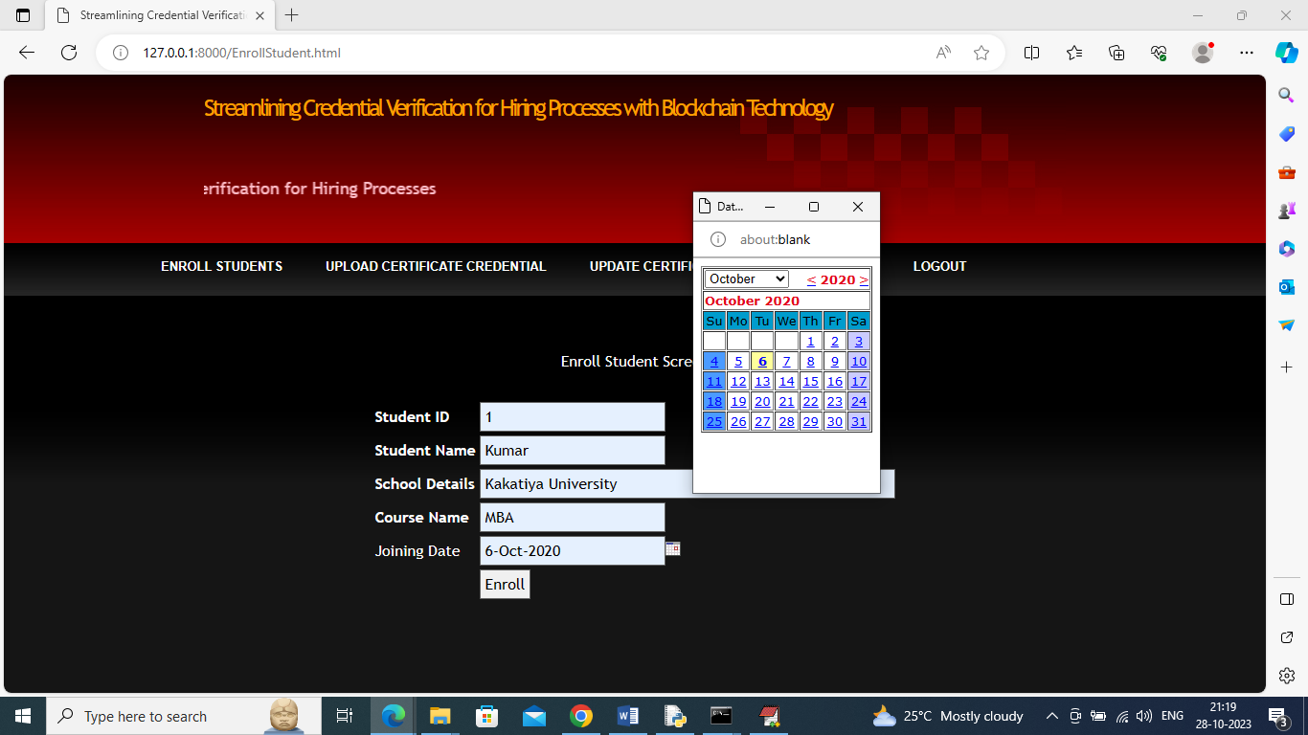

In above screen university is adding student details and then click on ‘Enrol’ button to save student details in Ethereum

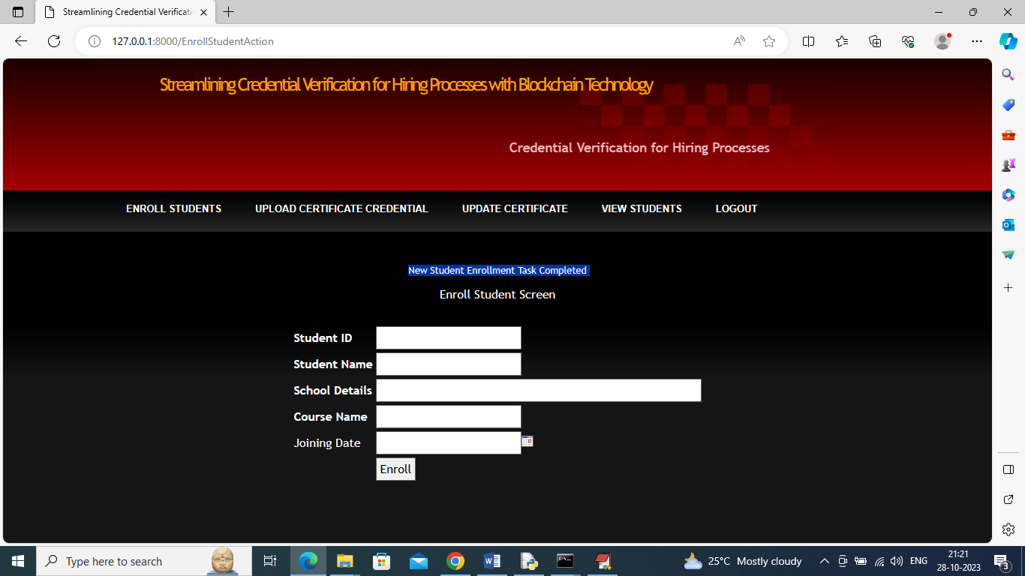

In above screen student details added and university can click on ‘Upload Certificate Credential’ link to upload student certificates in Blockchain

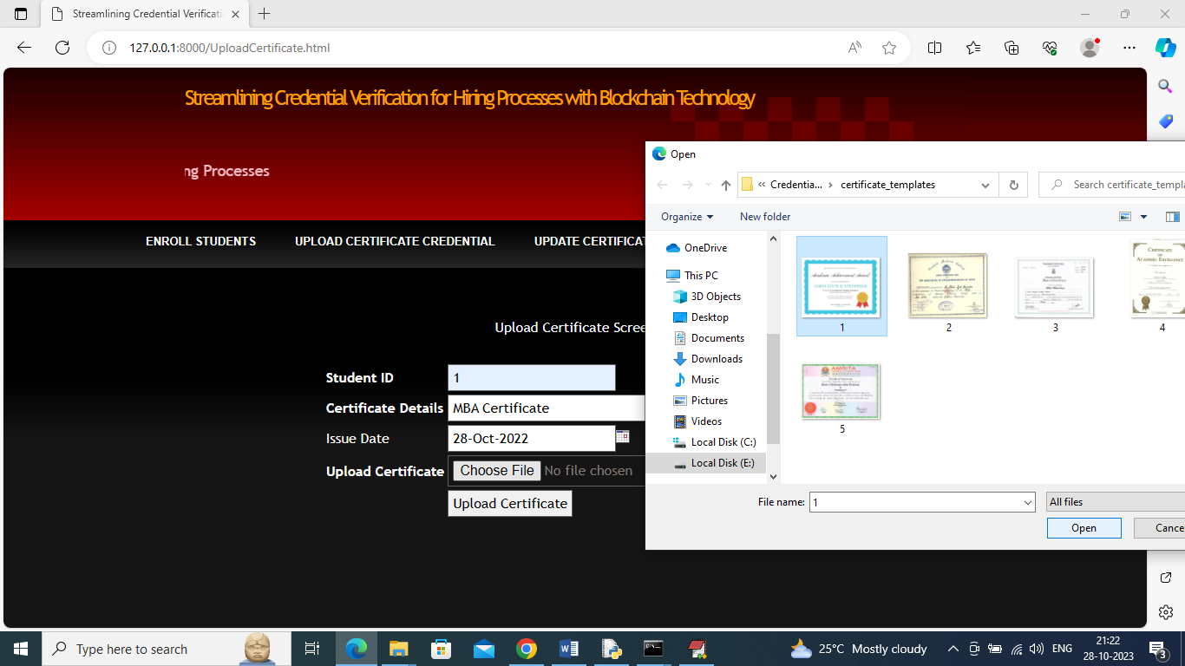

In above Screen University is uploading certificate for student ID 1 and then press button to save certificate in Ethereum

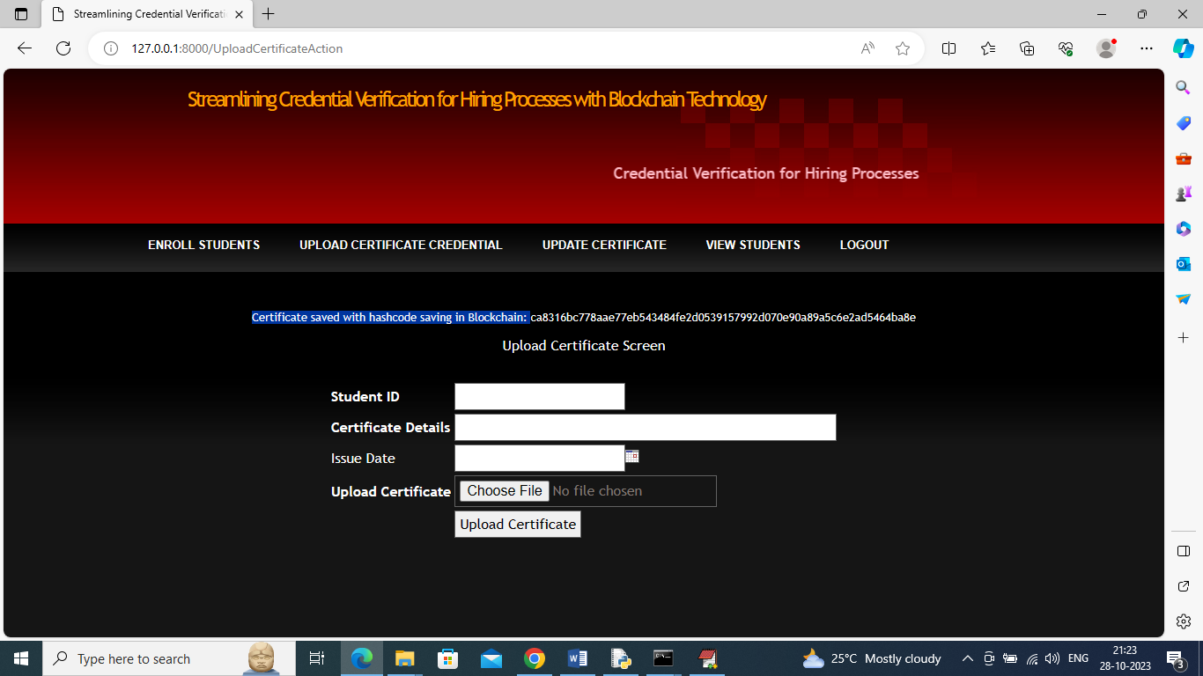

In above screen in blue colour text we can see certificate saved in Blockchain with displaying hashcode and under same student we can upload multiple certificates of different courses

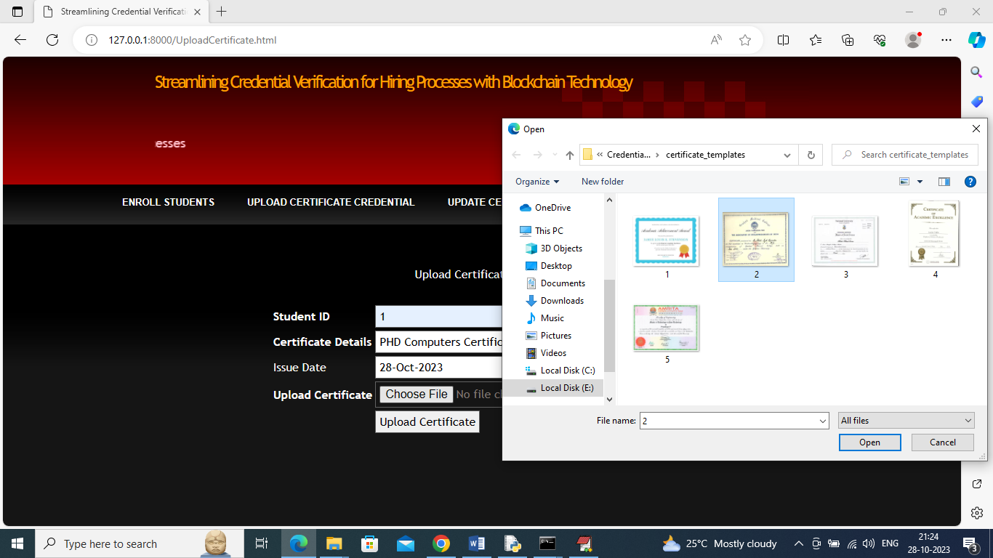

In above uploading another PHD certificate for same student and then press button to get below page

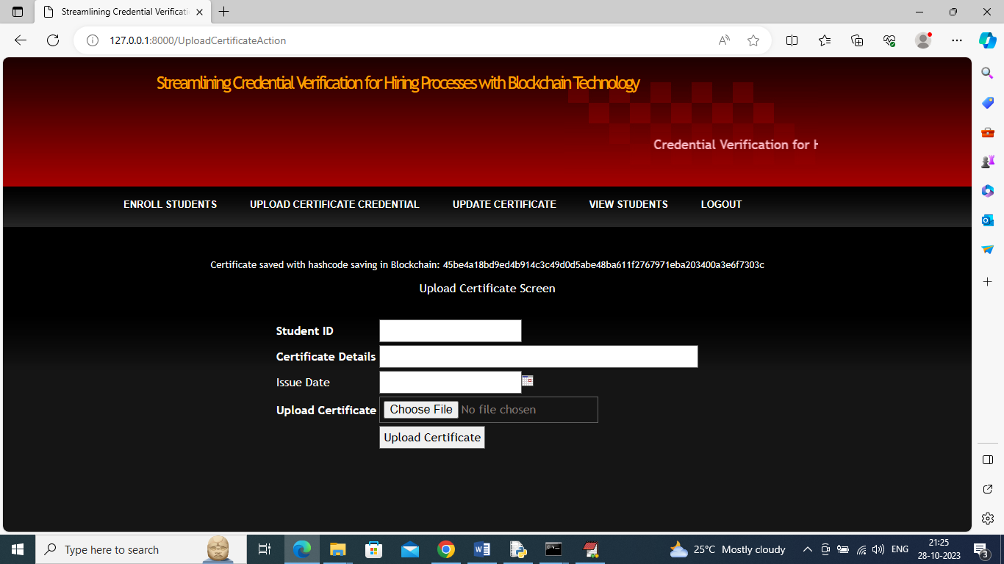

In above screen certificate details saved and now in above screen click on ‘Update Certificate’ link to upload certificate for same student if changes required in certificate

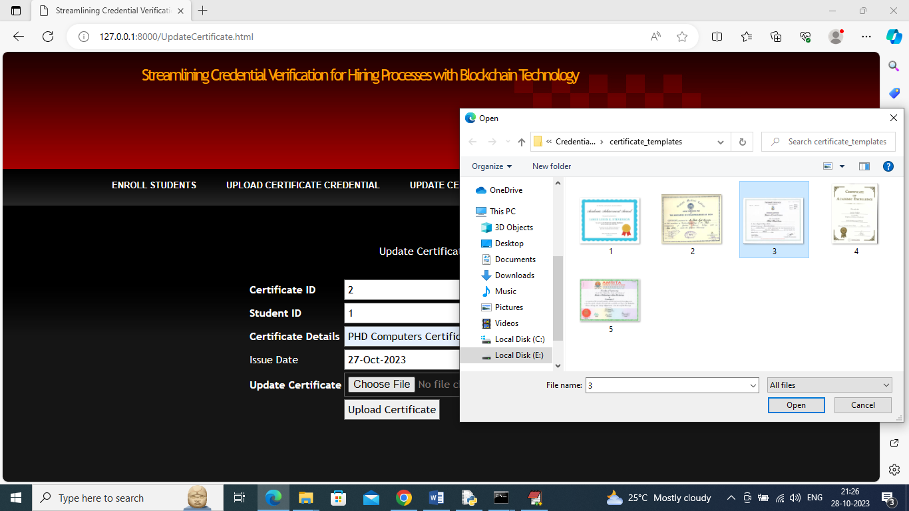

In above screen entering certificate and student id and then uploading modified certificate to make changes and get below screen

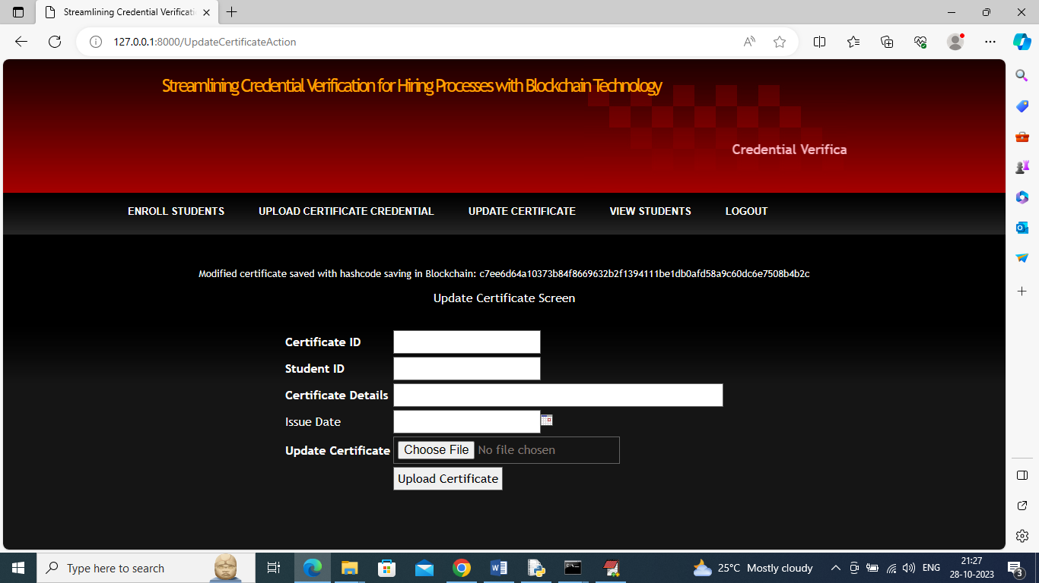

In above screen modified certificate saved in Blockchain and now click on ‘View Students’ link to view all student details

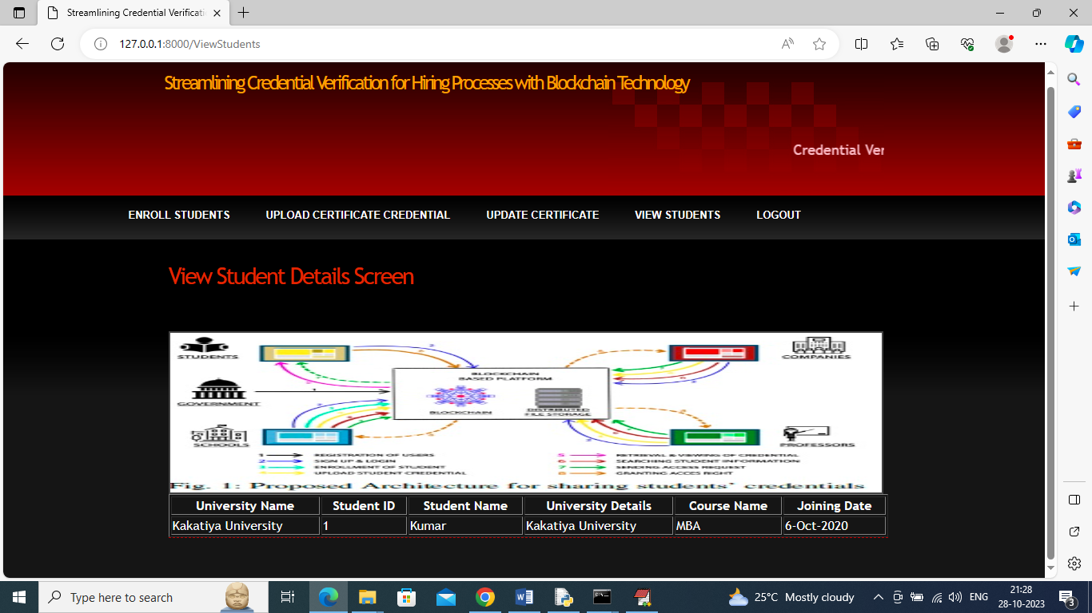

In above screen in tabular format we can see student details and now click on ‘Logout’ link and then login as company

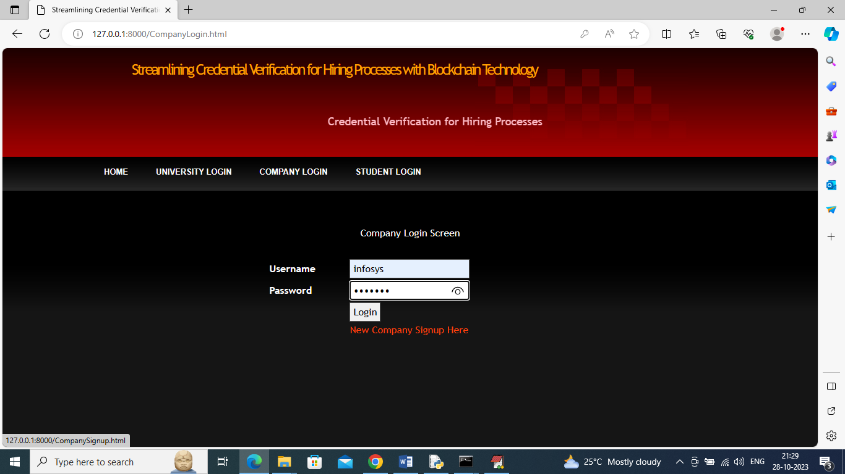

In above screen company is login and after login will get below page

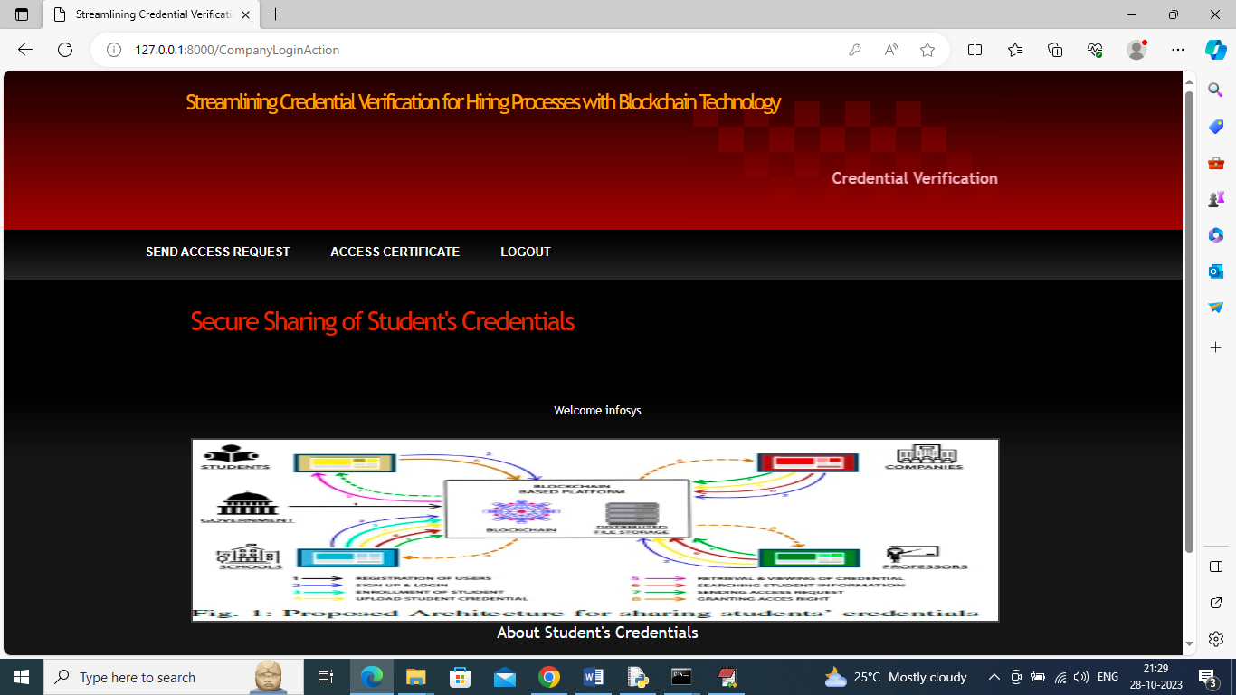

In above screen company can click on ‘Send Access Request’ link to view all student details

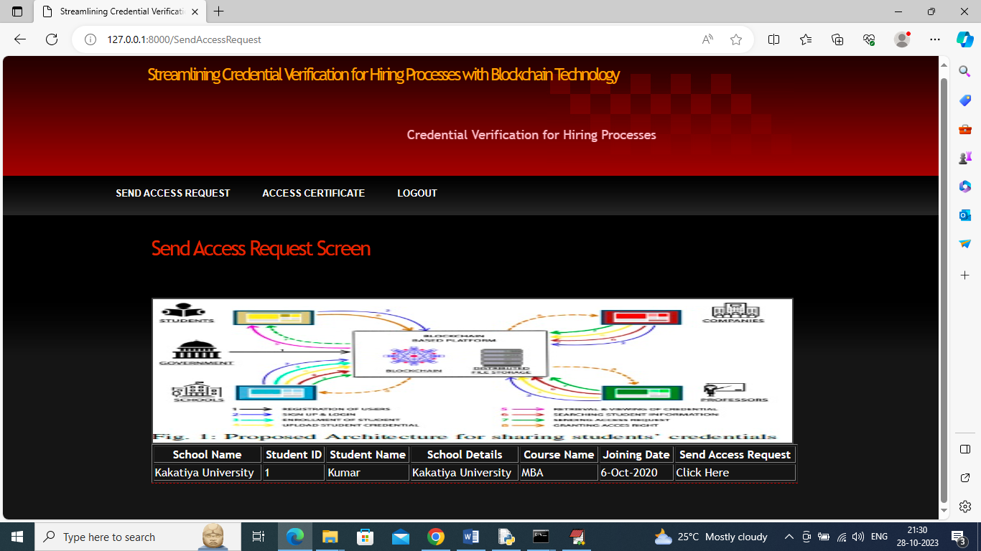

In above screen company can view all student and their course details and then click on ‘Click Here’ link to send access request to that student

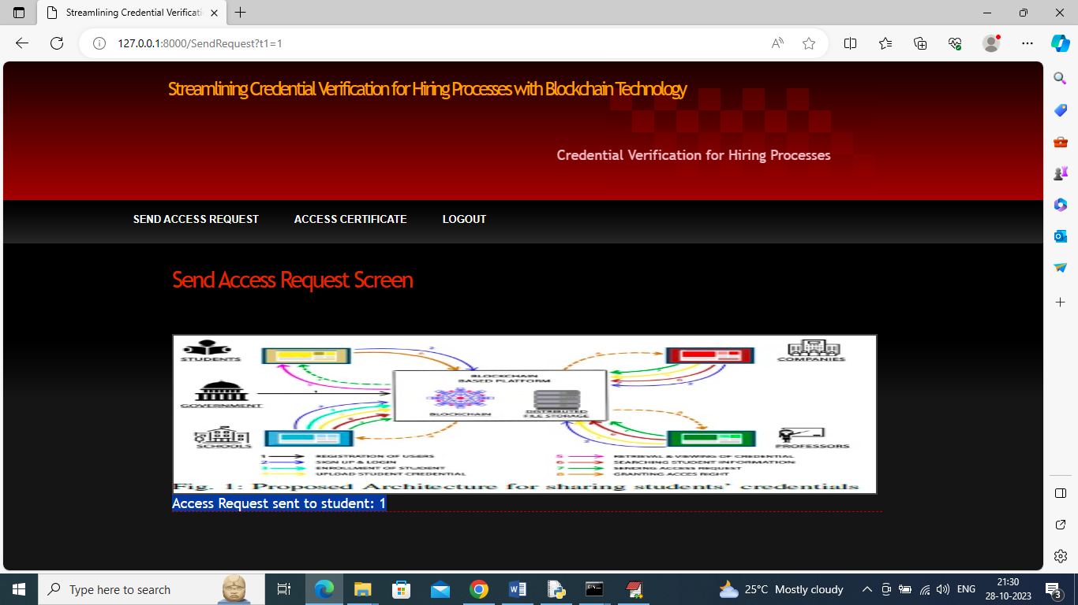

In above screen in blue colour text we can see access request sent to student ID 1 and now logout and login as student to approve company request

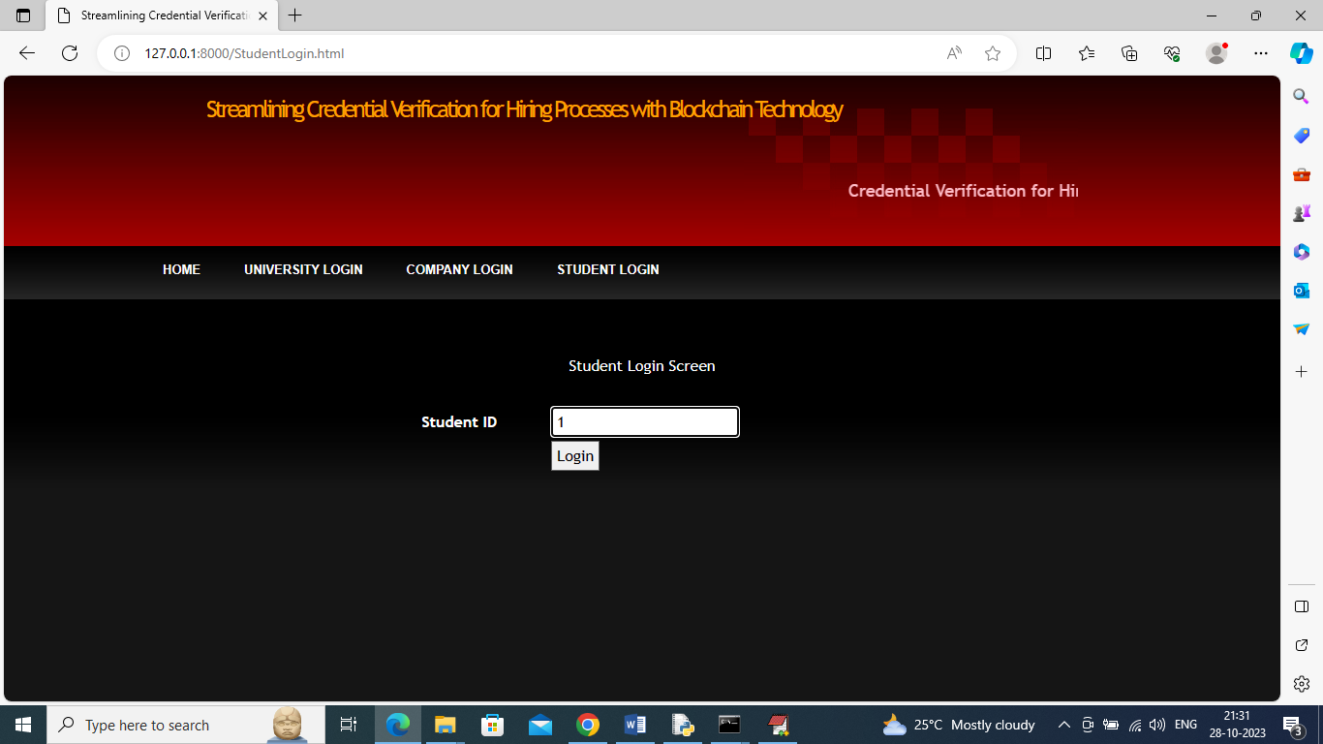

In above screen student is login by using his ID and then press button to get below page

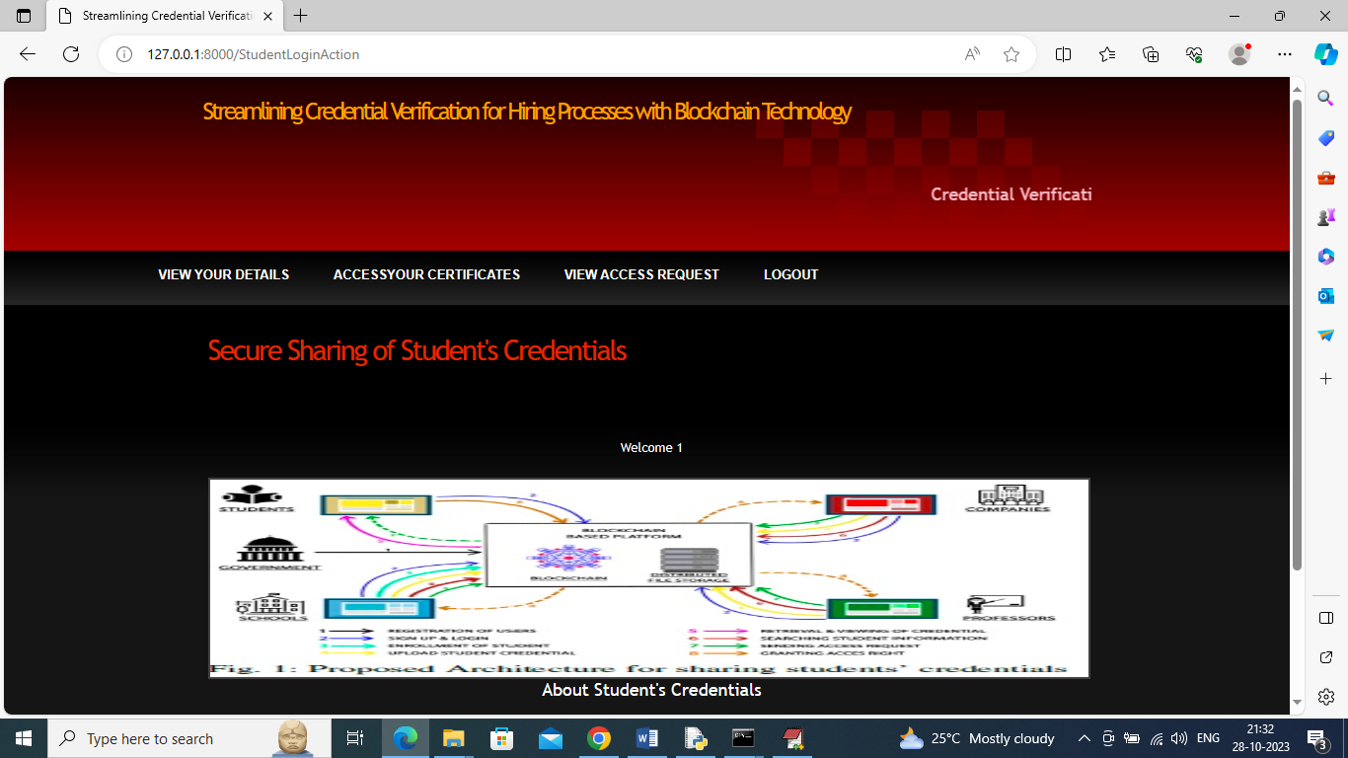

In above screen student can click on ‘View Your Details’ link to view their course details

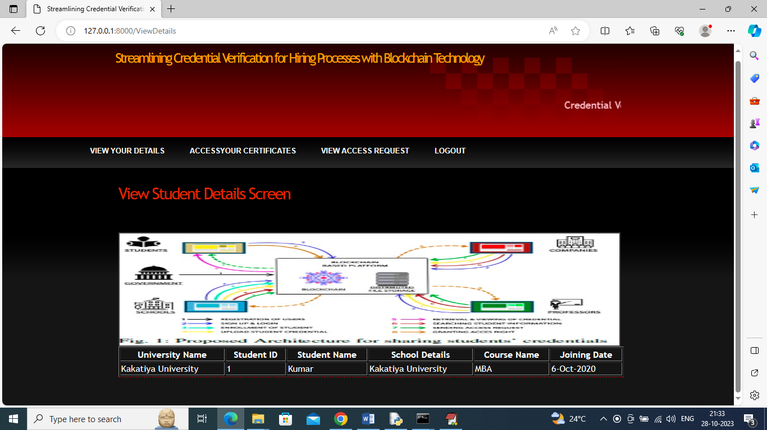

In above screen student can view his details and now click on ‘Access Your Certificate’ link to view their certificates like below screen

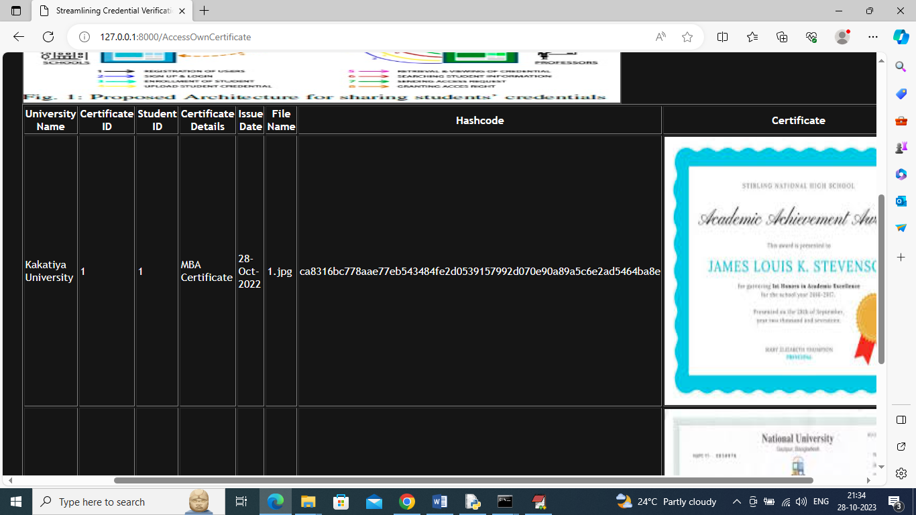

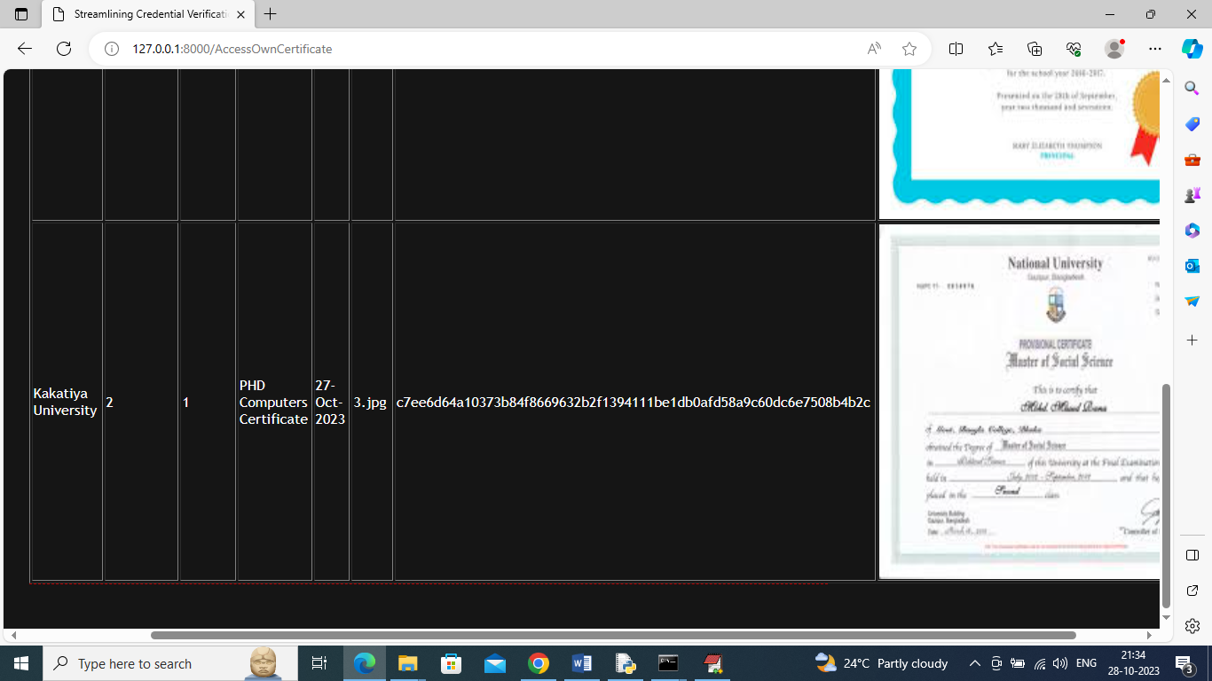

In above screen student can view all his certificates and now click on ‘View Access Request’ link to view request from companies

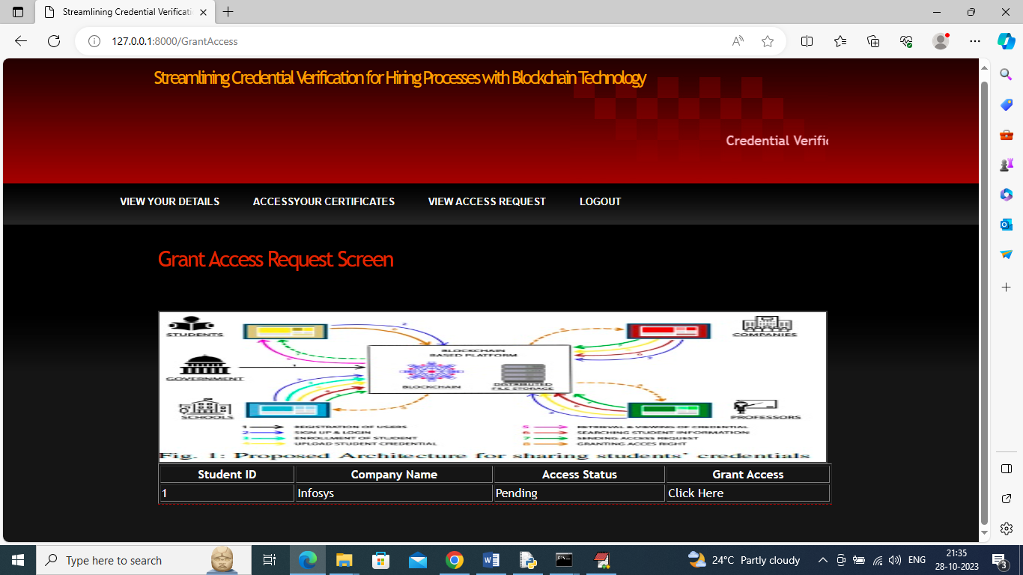

In above screen student can view company details and then click on ‘Click Here’ to approve request and get below page

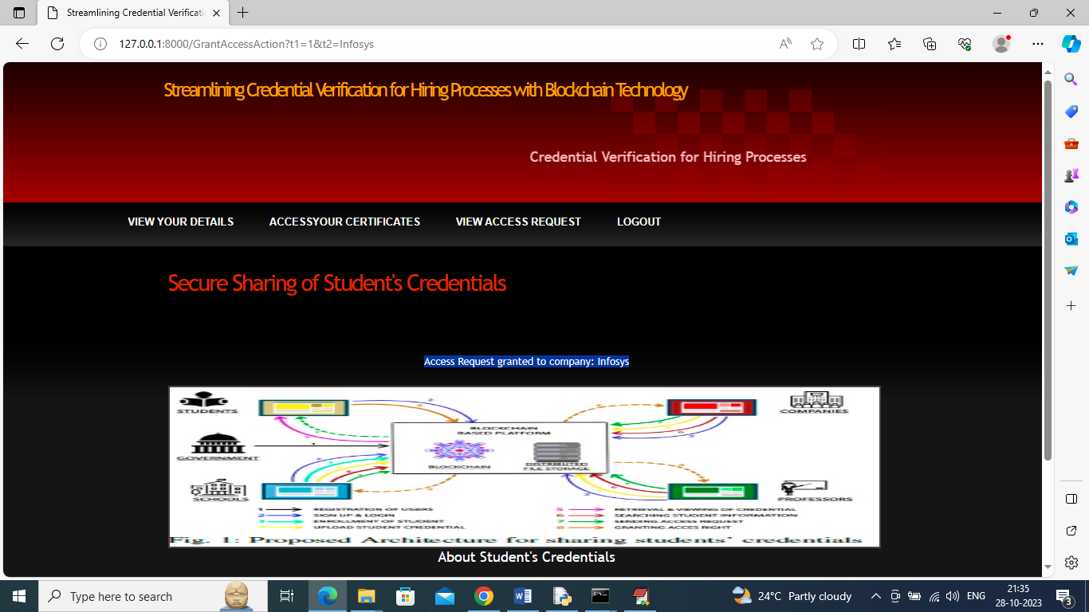

In above screen in blue colour text we can see Access Request Granted for given company and now logout and login as company so company can access granted certificates

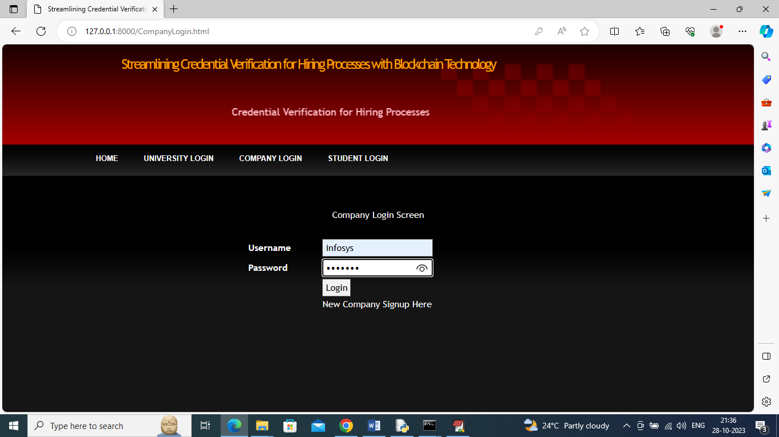

In above screen company is login and after login will get below page

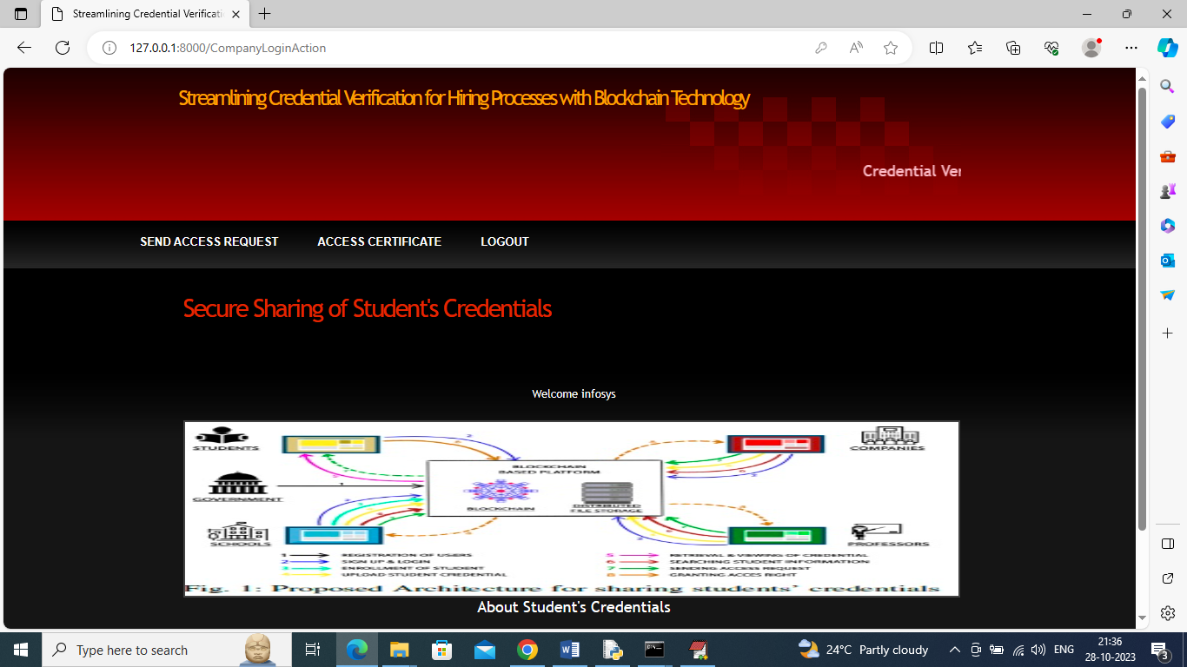

In above screen company can click on ‘Access Certificate’ link to view access granted certificates

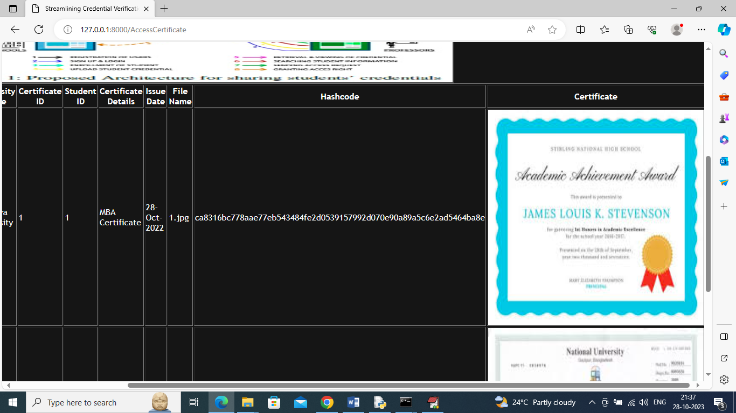

In above screen company can view all certificates of all students

Similarly by following above screens you can upload any number of student credentials to Blockchain